
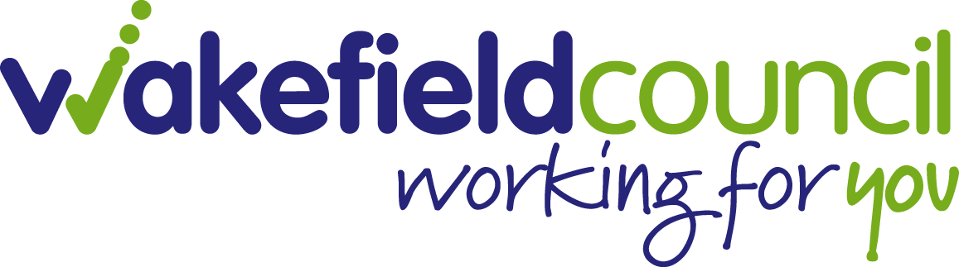
Job Advert
Liaison and Diversion (Kirklees)
1 x 37 Hour post until March 31st 2025
SCALE 18 – 22 (£24,982 to £27,041 per annum)
WomenCentre is working in partnership with Wakefield Council to provide a West Yorkshire L and D service funded by NHS England. WC will provide gender specific support for women at the point of arrest with a view to diverting them away from the Criminal Justice System into support services to address identified vulnerabilities to improve their health and well-being and reduce the risk of re-offending. The post will be based in Calderdale but offering strong links to our WomenCentre wider services.

About WomenCentre
WomenCentre has bases in Calderdale and Kirklees, from where we support women to make positive, long-term changes to their lives. We provide high quality services, advice and information, with an emphasis on holistic care of the woman and her family. Our main areas of service delivery are Domestic Abuse and Women’s Health and Wellbeing with our services reaching many women who are at points of crisis: women experiencing acute and chronic mental health difficulties; in contact with the criminal justice system; refugees and asylum seekers; women in poverty; those with drug and alcohol problems; and victims of domestic abuse. Women are supported to take control of their lives and their futures; to plan for their own health and wellbeing; and to build their confidence and ability to cope. Women are encouraged and supported to shape and contribute to the delivery of WC’s work.
About the Post
The successful applicants will join the L&D/WC teams and will be committed to supporting women through strong partnership working with external agencies including the police, courts and other statutory and voluntary sector services. This along with strong team working is essential in this role. The post will also be expected to contribute to the wider WY L and D all age offer and will be required to carry out assessments in police custody, probation, prison and community settings provide support for women to access wider mainstream and voluntary sector providers across Calderdale by signposting and supporting women coming into contact with the Criminal Justice System.

WomenCentre is an organisation that promotes safeguarding practice across all our service delivery and staff and volunteer recruitment.

Application deadline: 9am 27th October 2022
Short listing: 28th October 2022
Interviews to be held: 11th November 2022
For an informal discussion please contact Nicola Tutty, L and D Women’s Lead ntutty@wakefield.gov.uk
Tel 07825853231

For more information about the above post or to download an application pack please visit website: www.womencentre.org.uk.
All applications should be returned to:javeria.aurangzeb@womencentre.org.uk

This post is open to women only – Equality Act 2010, Schedule 9, Part 1 applies

www.womencentre.org.uk
Company number: 06084795 Charity number: 1118366

