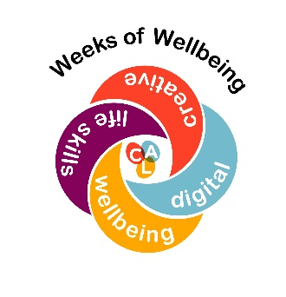
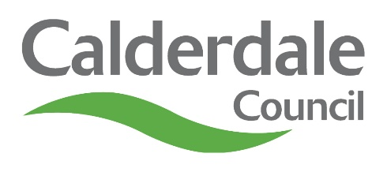
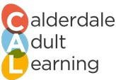

Platinum Jubilee WOW Programme
For residents of Calderdale
Monday 6th June | Tuesday 7th June | Wednesday 8th June | Thursday 9th June | Friday 10th June
Painting for Beginners  10:00am – 12:00pm  An Introduction to Dyslexia Awareness  10:00 – 11:00am | Learn How to Recycle  10:00 – 11:00am | Make the Most of You  10:00 – 11:00am  Cake Baking  6:00 – 8:30pm | How to Save a Life With CPR  10:00 – 11:00am  Get Me an Interview  1:00 – 2:30pm | An Introduction to Portuguese  10:00am – 12:00pm  Exploring Mindfulness  12:00 – 1:00pm
Monday 13th June | Tuesday 14th June | Wednesday 15th June | Thursday 16th June | Friday 17th June
Self Portrait Collage  10:00am – 12:00pm  Pilates for Beginners  11:45am – 12:45pm | Learn How to Recycle  10:00 – 11:00am  How to Save a Life with CPR  1:00 – 2:00pm | Afternoon Tea at the Palace  1:30pm – 3:30pm | 5 Ways to Help Your Mental Wellbeing  1:00 – 2:00pm  Yoga for Beginners  2:00 – 3:00pm | Creating Accessible Materials  10:00 – 11:30am  Bead Jewellery Making  10:00 – 11:30am
All courses are £5 except those in bold that are free
To enrol please email cyps.cal@calderdale.gov.uk or call 01422 392820
https://www.calderdale.gov.uk/believeachieve

