Mental Health Awareness and Combatting Loneliness

Mental Health Awareness week will take place from 9th-15th May 2022, and this year’s theme for the week is loneliness. Never before has it been more important to give mental ill health the time it deserves and break down the stigmas associated with this devastating and destructive illness that so many of us suffer with.
As many people will be aware, one of the big contributing factors to mental ill heath these days is loneliness. We know that loneliness is affecting more and more of us in the UK and has had a huge impact on our mental health, not least because of the pandemic and ongoing lockdowns we have all experienced.
We know that our connection to other people and our community is paramount to protecting our mental health, and as such, we all need to work together to find better ways to tackle loneliness, both within ourselves and within others. Because reducing loneliness is a major step towards to more healthy society.

Loneliness and its impact on our mental health
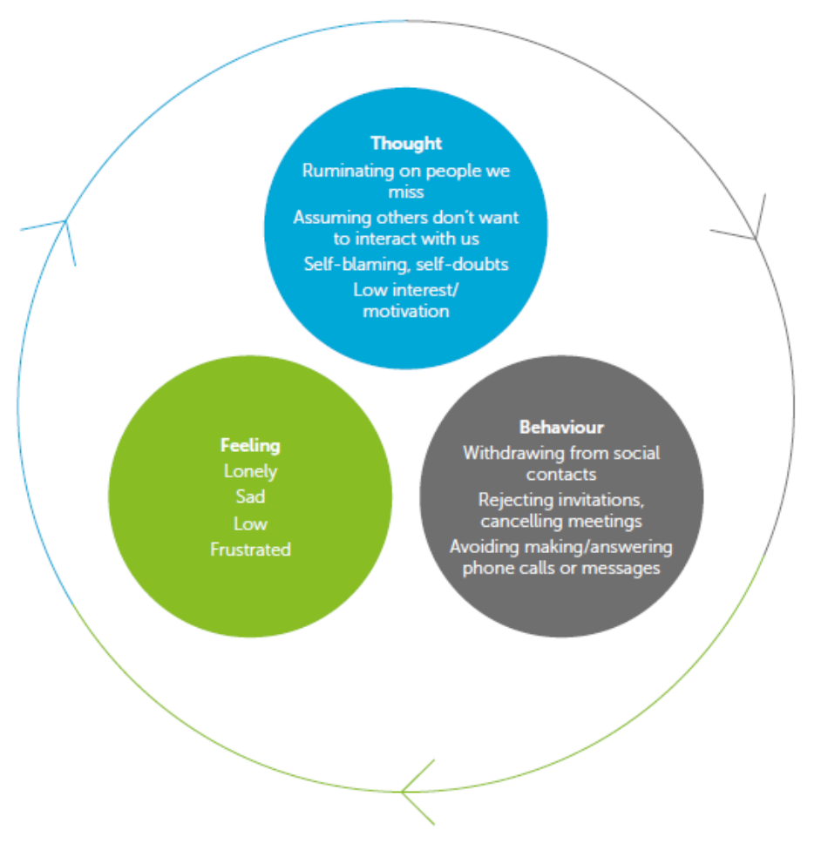
Loneliness is a normal human feeling, which almost everyone will experience at some point in their lives.
Generally, it presents itself in a feeling of being isolated or disconnected from others. It may also manifest itself as a feeling of not being understood or cared for.
When we are on our own, but don’t want to be, it’s natural for us to feel a bit lonely and sad. We may start thinking in a negative or self-critical way, which can lead to low motivation and social withdrawal. Without active coping strategies, this pattern may continue to make our mood even lower and result in more negative thoughts and avoidance responses. This is what we call the vicious cycle of loneliness.
VitaMinds is here for you.


Arrange an appointment

Scan the QR code

Call us on 0333 0153 494

Ask your GP to refer you to Vita vitahealthgroup.co.uk

